***COME AND EXPERIENCE THE BEAUTY OF A SOUND BATH.***

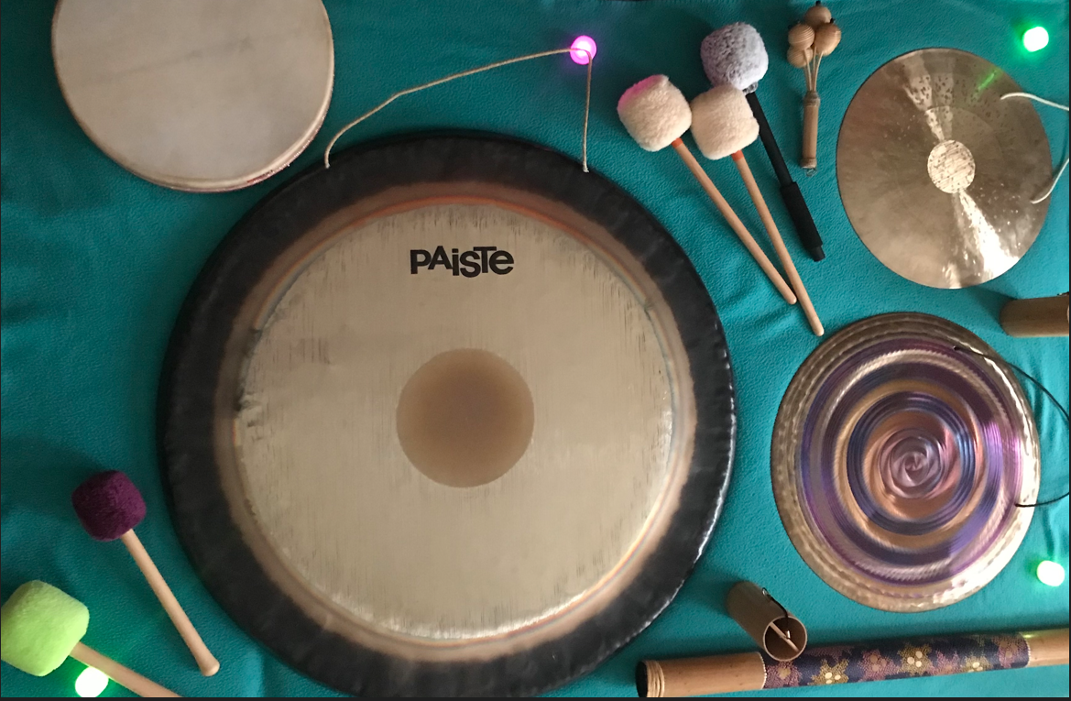

***LET THE GONG SOUNDS SOOTHE YOU AND BRING SOME RELAXATION TO YOUR DAY.***

***Close to the Super Full Moon in Aries, we will be gently caressing our souls with sounds, to connect with the higher self and allow for powerful healing.***

***Sunday 13th October 2024:*** [***https://goingforagong1024.eventbrite.co.uk***](https://goingforagong1024.eventbrite.co.uk)

***11:30am – 12:30 pm at Waterloo Action Centre (Rear Hall).***

***Address: WAC, 14 Bailys Road, SE1 7AA.***

***Closest stations: Waterloo, Southwark, Lambeth North.***

***Please arrive 5/10 minutes early, late comers won’t be allowed. Yoga mats provided but best to bring a blanket.***